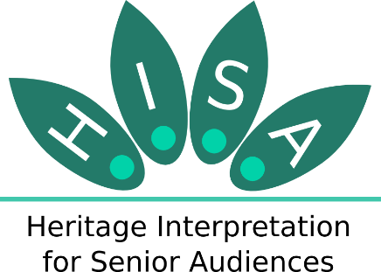
Heritage Interpretation for Senior Audiences

A good practice checklist for interpretation managers

No | Recommendation | Check
Before the visit
1 | Provide clear information about the accessibility of the site in your website and in written material.
2 | Provide information on the website about the availability of wheelchairs or other aids, and make these easily available onsite.
3 | Be aware of psychological barriers, such as fear of heights or claustrophobia, and encourage group leaders to visit before
Arrival
4 | Provide accessible car parking close to the site.
5 | Make sure there is easy and well-signed access to the site from public transport.
Orientation
6 | Provide clear signage to, and around, the site, that has good contrast, commonly recognised symbols and clear fonts.
7 | Where appropriate, provide short and clear audio announcements about closing times, special tours and other activities.
8 | Clearly show the location of a lift if present.
During the visit
9 | Make sure the site is suitable for people with mobility issues.
10 | Provide seating at regular intervals around the site, and make sure its location is made clear to visitors.
11 | Make sure there is good, even lighting, particularly on stairs, in toilets and on signs or written information.
12 | Provide audio-visual material and make sure it is properly trialled and tested by people with visual and hearing impairments.
13 | Treat people of all ages as equals. Make no assumptions about visitors’ knowledge of the site.
14 | Plan and deliver interpretation as a comprehensive programme to explain the site to visitors with a range of interests, experiences and education levels.
15 | Provide ‘layered interpretation’ at a variety of levels, that includes a simple overview and more ‘in-depth’ explanations. Give people the option to find out more detail in publications or websites.
16 | Be aware of multiple interests in visitors, and their varied experiences and education levels.
17 | Provide a range of interpretive media including personal, printed, animation, film, music and digital.
18 | Provide interpretation that involves using different senses, including smells, sounds and fun activities.
19 | Offer opportunities for visitors to record their reminiscences and memories about the site or its features.
20 | Offer inter-generational activities and themed events for visitors to share their knowledge and skills.
21 | Spark memories and imagination in visitors by including historical images, text and other items in the interpretation materials.
22 | Provide space, and a café, for rest and contemplation.
23 | Provide child-free time slots for seniors.
24 | Communication with visitors as if you are having a ‘two-way conversation’, not just explaining the site in a ‘one-way monologue’. Communicate with people, rather than talk at them.
25 | Be patient and give people time to understand and tell their own stories so their experiences are personalised, and use these stories as part of your interpretation of the site.
End of visit
26 | Say thank you and invite feedback.

